**Database Title**

# Project Team (3 students)

|  |  |  |
| --- | --- | --- |
| **No** | Stu-Number | Name Surname |
| 1 | Berkın Akbıyık | 17070001013 |
| 2 | Selin Çetiner | 17070001002 |
| 3 |  |  |

**PHASE 4- USER INTERFACE (Due Jan, 10)**

# Graphical User Interface

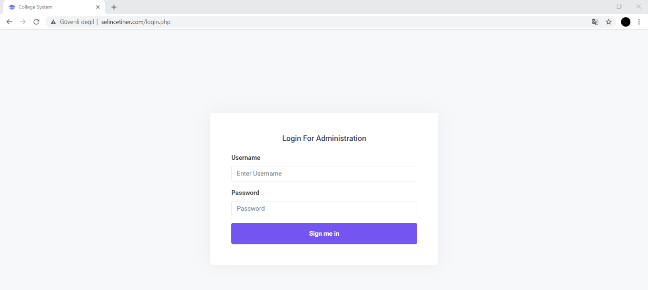

Login screen

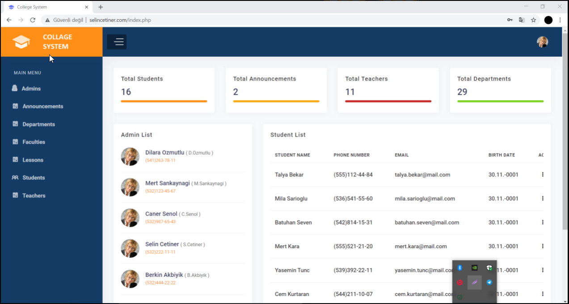

User list

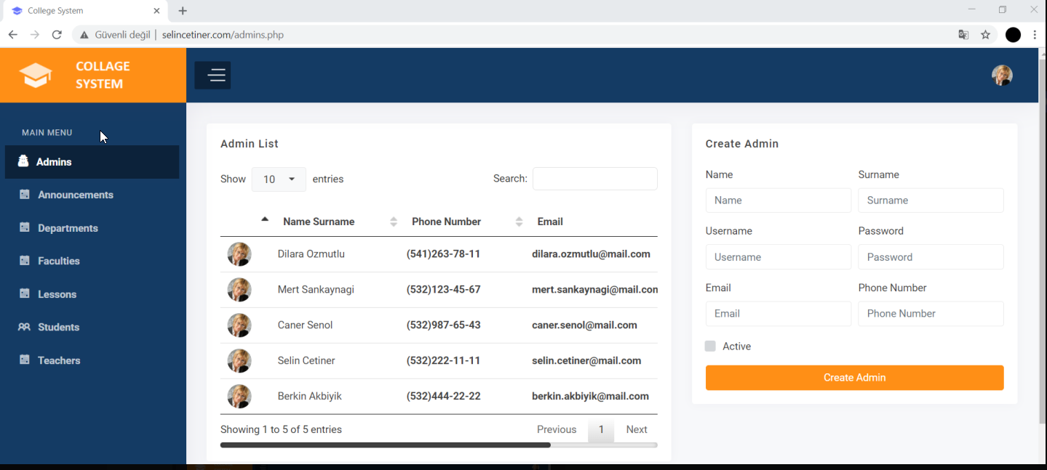

Create admin

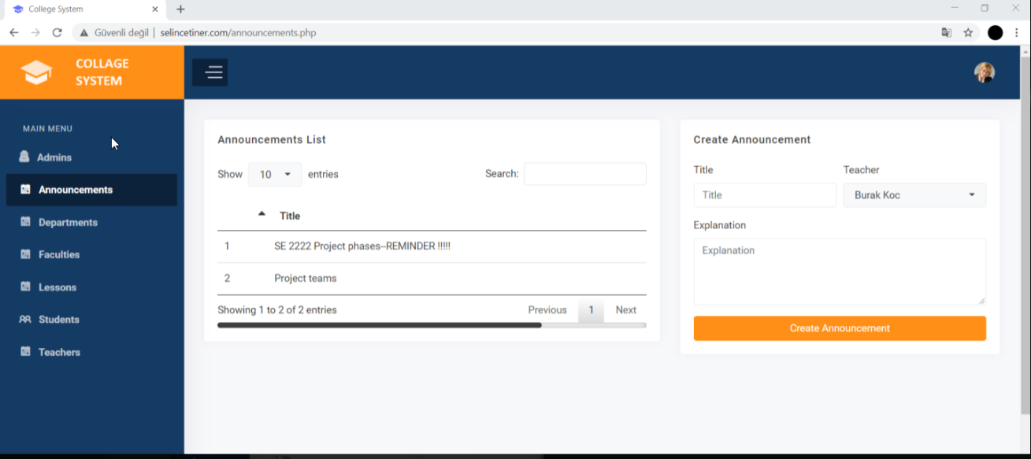

Create announcement

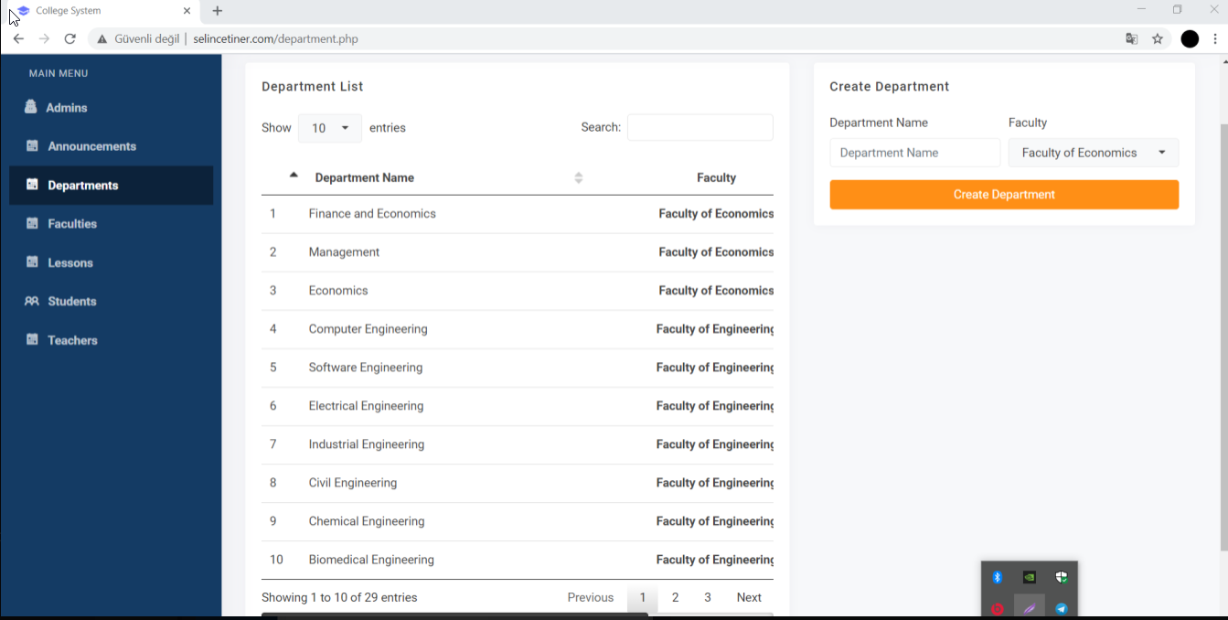

Create department

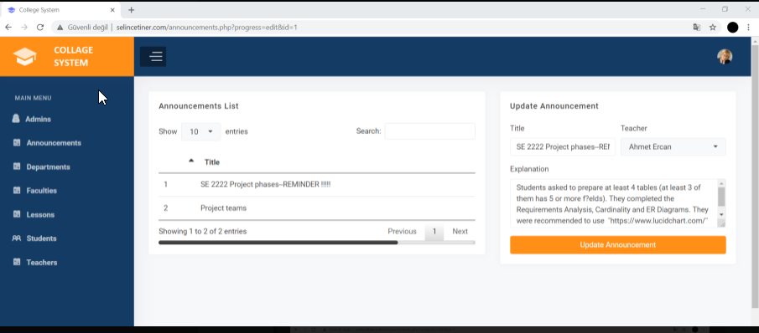

Update announcement

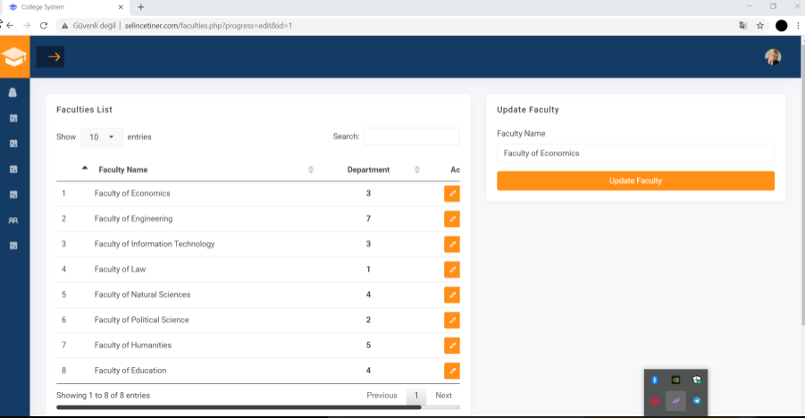

Update faculty

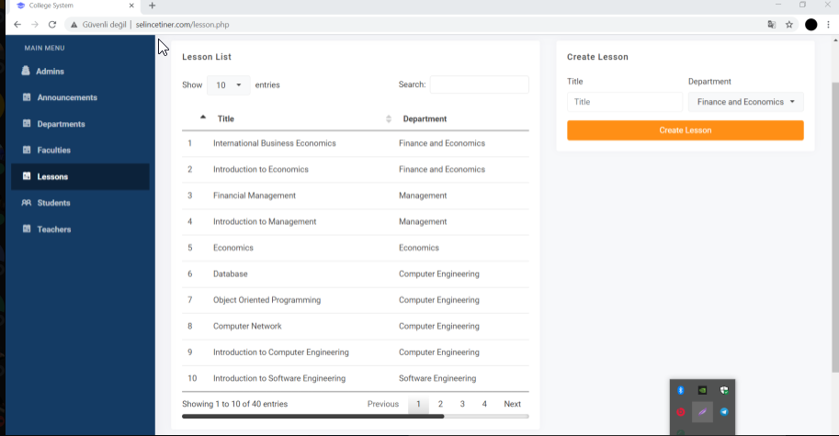

Create lesson

metin, ekran görüntüsü, dizüstü içeren bir resim

Açıklama otomatik olarak oluşturuldu

Create teacher

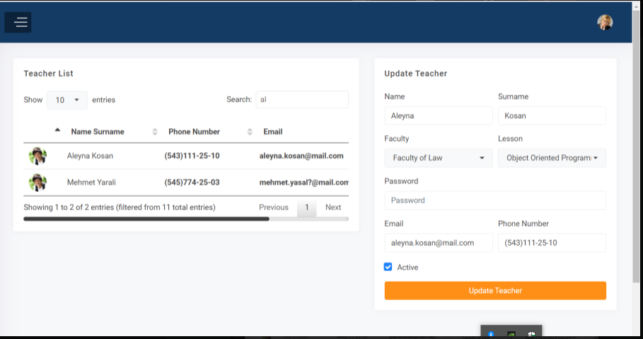

Update teacher

We use phpMyAdmin To see our database and also learn it.

metin içeren bir resim

Açıklama otomatik olarak oluşturuldu

announcement

tablo içeren bir resim

Açıklama otomatik olarak oluşturuldu

department

metin içeren bir resim

Açıklama otomatik olarak oluşturuldu

faculty

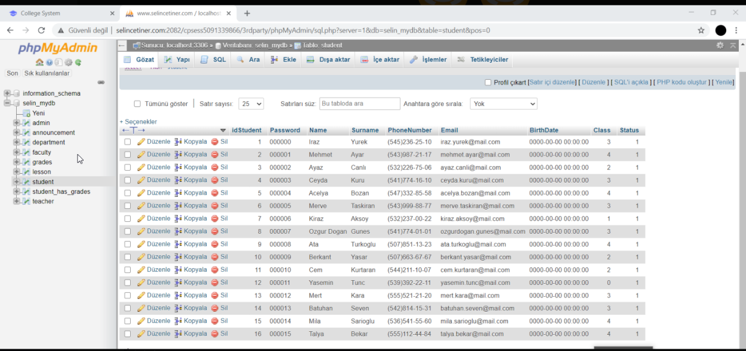

student

tablo içeren bir resim

Açıklama otomatik olarak oluşturuldu

teacher

# Presentation

# Discussion and self-evaluation

in this project, we tried to create a database and use it. for this purpose, we have implemented our own database with the tasks given in each phase in weeks. We did this by creating the first phase and drawing the ER Diagram that included SQL instances . 2nd the phase was about improving the database that we created, so we normalized it by finding functional dependencies and updated our database so that it was not subject to repetition. In third, as for the phase, mysql also learned 3 topics that we are not used to, and we used them on our own database and got the results. As for the end, we created our own interface and moved our database to real life. As a result, the project taught us a lot of things we didn't know and allowed us to consolidate what we knew. I think this system can be used comfortably in schools and colleges by improving the safety stages and making a few more improvements.

# Peer-Review ? (table filled)

Write here for each member of your group, list of gains, benefits

There will also be a peer evaluation session on SAKAI.

**Berkın**: How to create and use database, thinking to reduce anomalies, improving consistency, functional dependency, using of group by/order by etc. mysql keywords, forward engineering on development, constraints, triggers, assertions, cardinality, insert and delete implementations for database.

**Selin**: Implementing database system, testing a database, normalization rules, using mysql, collage management systems, constraints, triggers, assertions, functional dependency, er diagrams, insert and delete implementations for database.

Phase 2 sql screenshots

# SQL Examples

Show the syntaxes and give 2 examples for each

## SELECT ?

Select * from lesson;

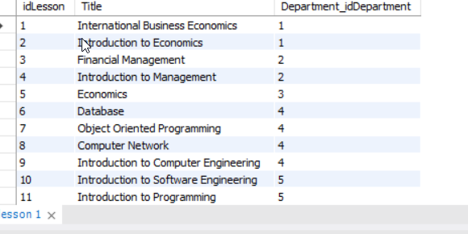

Select stddev(quizGrade) from grades;

metin içeren bir resim

Açıklama otomatik olarak oluşturuldu

## DISTINCT ?

Select distinct name from student;

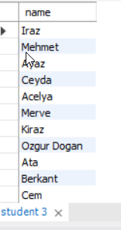

Select distinct hwgrade from grades;

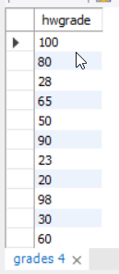

## WHERE ?

Select Faculty_idFaculty from department where DepartmentName='Industrial Engineering';

metin içeren bir resim

Açıklama otomatik olarak oluşturuldu

## AND/OR ?

Select Lesson_idLesson from grades where (quizgrade=100) and (midtermgrade=100);

tablo içeren bir resim

Açıklama otomatik olarak oluşturuldu

Select surname from grades where (finalgrade>75) or (hwgrade<70);

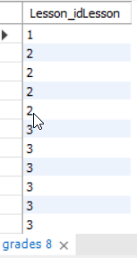

## BETWEEN

 Select* from grades where quizgrade between 10 and 20;

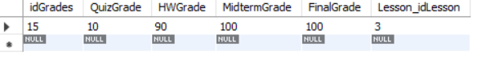

Select* from grades where finalgrade not between 25 and 85;

tablo içeren bir resim

Açıklama otomatik olarak oluşturuldu

## ORDER BY ?

select name from teacher ORDER BY Status asc;

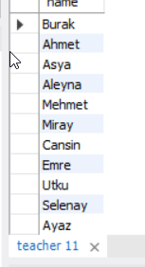

## GROUP BY?

Select count(name), class from student group by class;

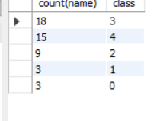

Phase 3 Constraints

# Constraints Examples x 3 (with view snapshots)

## KEY

metin içeren bir resim

Açıklama otomatik olarak oluşturuldu

**Primary key constraint**= PRIMARY KEY (`idDepartment`),

**Foreign key constraint** = FOREIGN KEY (`Faculty_idFaculty`)

**Not null constraint** = `idDepartment` INT NOT NULL AUTO_INCREMENT, `Faculty_idFaculty` INT NOT NULL,

## VALUE-BASED

metin içeren bir resim

Açıklama otomatik olarak oluşturuldu

check(status<5),

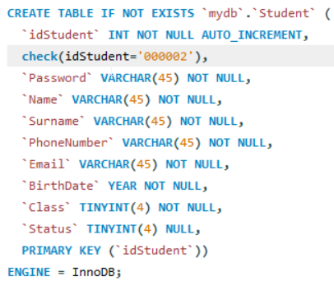

check(idStudent='000002'),

metin içeren bir resim

Açıklama otomatik olarak oluşturuldu

check(FinalGrade>90),

## TUPLE-BASED

metin içeren bir resim

Açıklama otomatik olarak oluşturuldu

`Lesson_idLesson` INT NOT NULL check(Lesson_idLesson>3),

metin içeren bir resim

Açıklama otomatik olarak oluşturuldu

`Status` TINYINT(4) NULL check(status>5),

metin içeren bir resim

Açıklama otomatik olarak oluşturuldu

`PhoneNumber` VARCHAR(45) NOT NULL check(PhoneNumber='(545)998-05-05'),

## COMPLEX CHECK

Not supported on mysql workbench.